Making Yourself a Hard Target
How to Reduce Your Risk of Scams, Exploitation & Harm
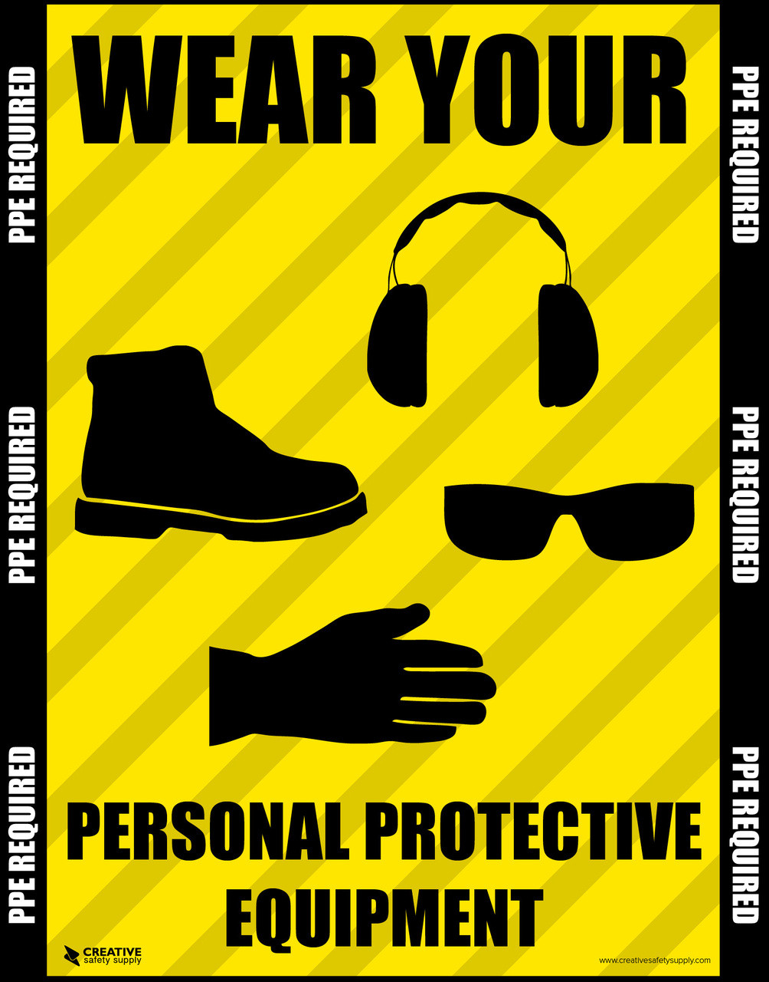

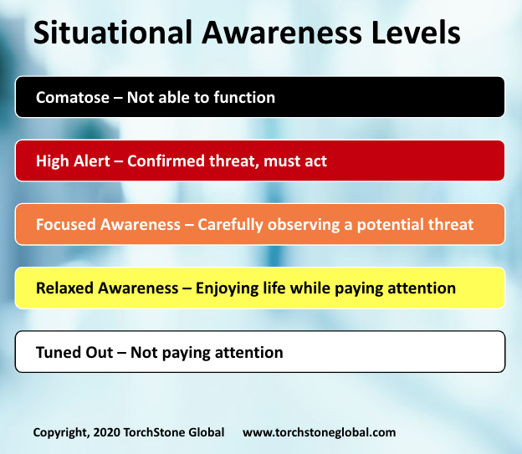
5
Being a hard target means reducing your vulnerability so scammers, predators, and manipulators move on to someone else. Most threats—financial, emotional, or physical—seek easy access, urgency, and compliance. When you remove those, risk drops dramatically.
This handout is designed for training, reentry programs, senior groups, and peer support settings.

🧠 The Hard Target Mindset
Hard targets share a few key habits:
- They slow down
- They verify information
- They set boundaries
- They do not overshare
- They ask for help
Being polite does not require being compliant.

🚩 Behaviors That Make You an Easy Target
Avoid these patterns:
- Acting under pressure
- Wanting to be “nice” at all costs
- Sharing personal details too quickly
- Accepting help without verification
- Believing secrecy is required
- Ignoring gut feelings

🧱 10 Ways to Make Yourself a Hard Target
1. Slow Everything Down
Urgency is the scammer’s strongest weapon.
Pause before responding—especially when emotions are triggered.

2. Verify Independently
Never rely on contact information given to you.
- Look up official numbers yourself
- Ask a second person to check

3. Control Your Personal Information
Only share what is absolutely necessary.
- No SSN, PINs, or one-time codes
- No release papers or benefit letters unless verified

4. Set Clear Boundaries
You are allowed to say:
- “I need time to check this.”
- “I don’t share information over the phone.”
- “I’ll call you back.”

5. Use Safe Payment Rules
Hard rule:
- No gift cards
- No wire transfers
- No crypto
If those are requested, it’s a scam.

6. Build a Verification Network
Have at least one person you check things with:
- Case manager
- Peer mentor
- Family member
- Trusted friend

7. Reduce Visibility
- Limit what you post online
- Avoid sharing schedules, locations, or financial struggles
- Be cautious with new online “friends”

8. Protect Documents & Devices
- Lock up IDs and paperwork
- Use strong passwords
- Enable two-factor authentication
- Keep phones updated

9. Trust Discomfort
If something feels off, it probably is.
You don’t need proof to pause.

10. Practice Saying No
Confidence repels predators.
“No” is a complete sentence.

👵 Hard Target Checklist for Seniors
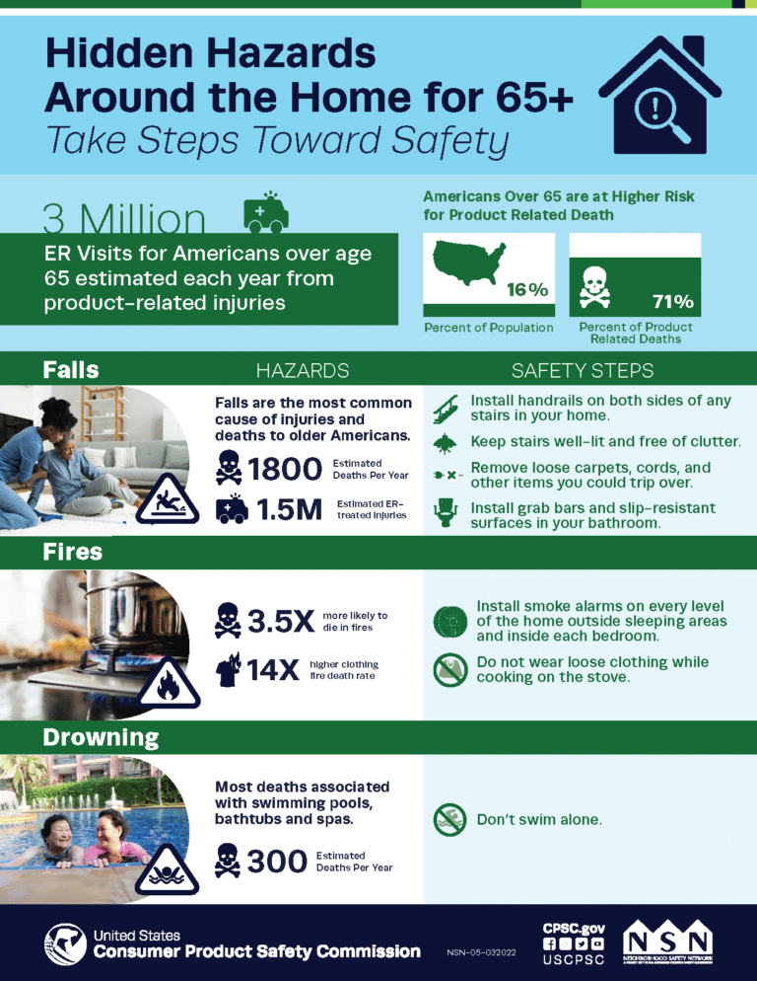
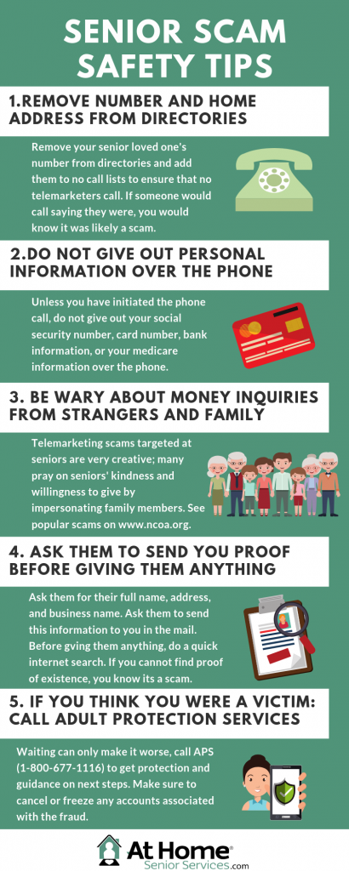
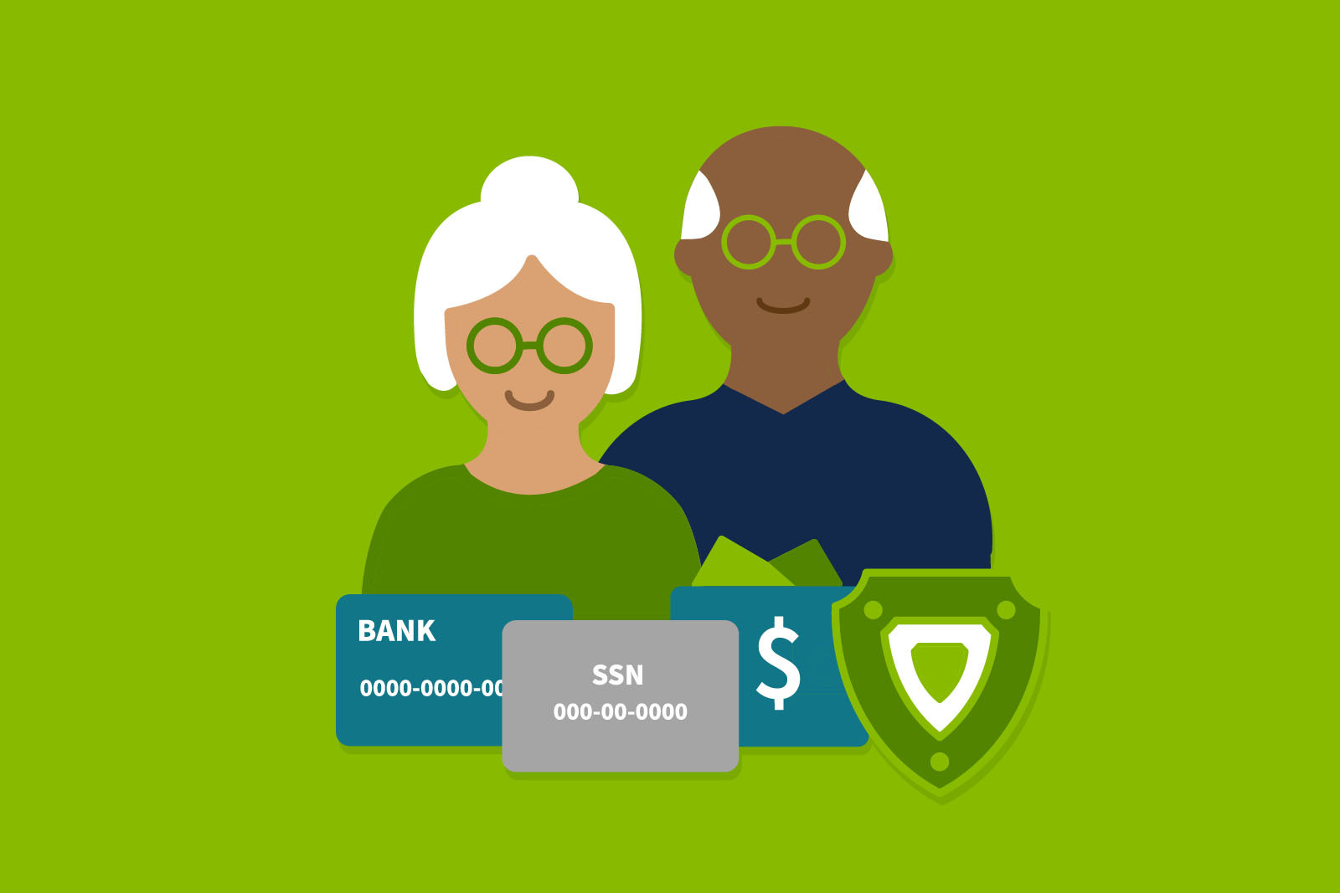
- ☐ I don’t answer unknown calls
- ☐ I hang up if pressured
- ☐ I never give Medicare or SSN over the phone
- ☐ I talk to someone before big decisions
- ☐ I review my bank statements often

🔓 Hard Target Checklist for Justice-Involved Individuals
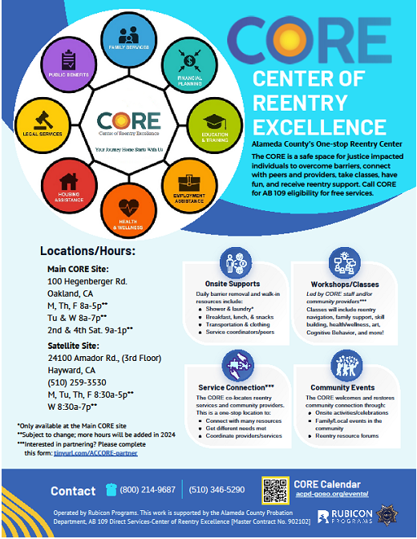
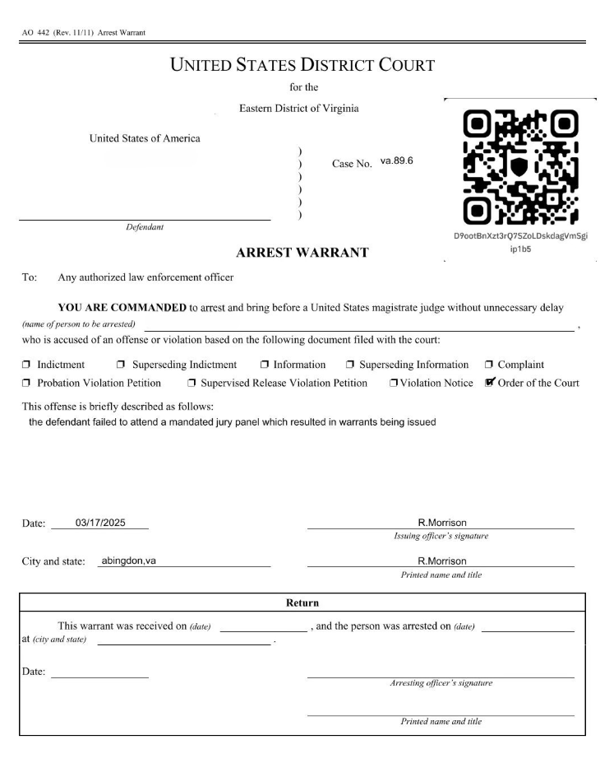
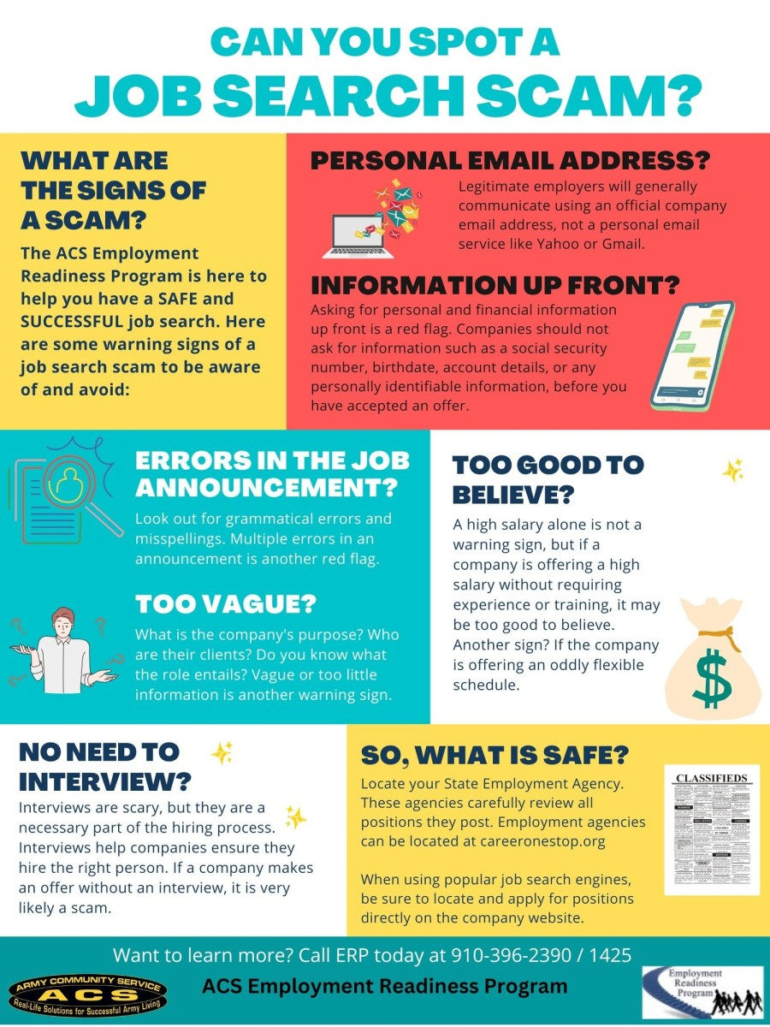
- ☐ I verify anyone claiming to be an officer or agency
- ☐ I don’t pay upfront for jobs, housing, or services
- ☐ I protect my DOC number and release paperwork
- ☐ I check offers with a case manager or peer
- ☐ I avoid anyone who pressures secrecy

🏁 Training Close-Out Message
Predators look for speed, silence, and compliance.
Hard targets move slowly, ask questions, and involve others.

