Avoiding Being Scammed: Practical Tips to Protect Yourself
By Thomas Toomey
Scams target people during moments of change, stress, isolation, or trust. Anyone can be scammed—but knowledge and awareness are powerful protection tools.
This handout will help you:
- Recognize common scams
- Protect your money and personal information
- Know what to do if something feels wrong

🚩 Universal Scam Warning Signs (Learn These First)
If any of these appear, stop and slow down:
- Pressure to act immediately
- Requests to keep it secret
- Demands for payment via gift cards, wire transfer, crypto, or prepaid cards
- Unexpected contact asking for personal information
- Promises of guaranteed money, prizes, or jobs
- Threats involving arrest, benefits loss, or account closure
👉 Real organizations do not rush, threaten, or demand secrecy.

📞 Phone, Text & Email Safety Rules
- Do not trust caller ID alone (it can be faked)
- Never share:
  - Social Security number
  - PINs or passwords
  - One-time security codes
- Hang up and call back using an official number
- Do not click links in unexpected messages
- Delete suspicious texts and emails

💳 Money & Identity Protection Basics
- Use strong, unique passwords
- Enable two-factor authentication
- Check bank statements often
- Never lend your identity or bank account to anyone
- Keep documents secure (ID, release papers, benefits letters)

🛑 What To Do If Something Feels Off
- Pause
- Do not send money
- Do not share information
- Talk to a trusted person
- Verify independently

✅ SCAM SAFETY CHECKLIST FOR SENIORS
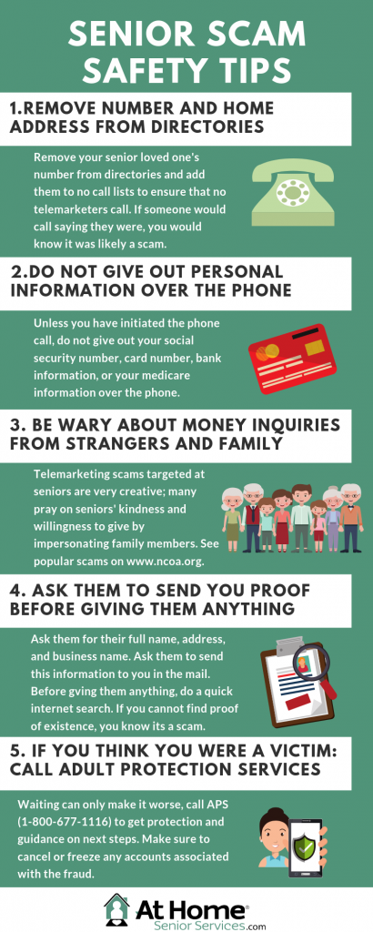

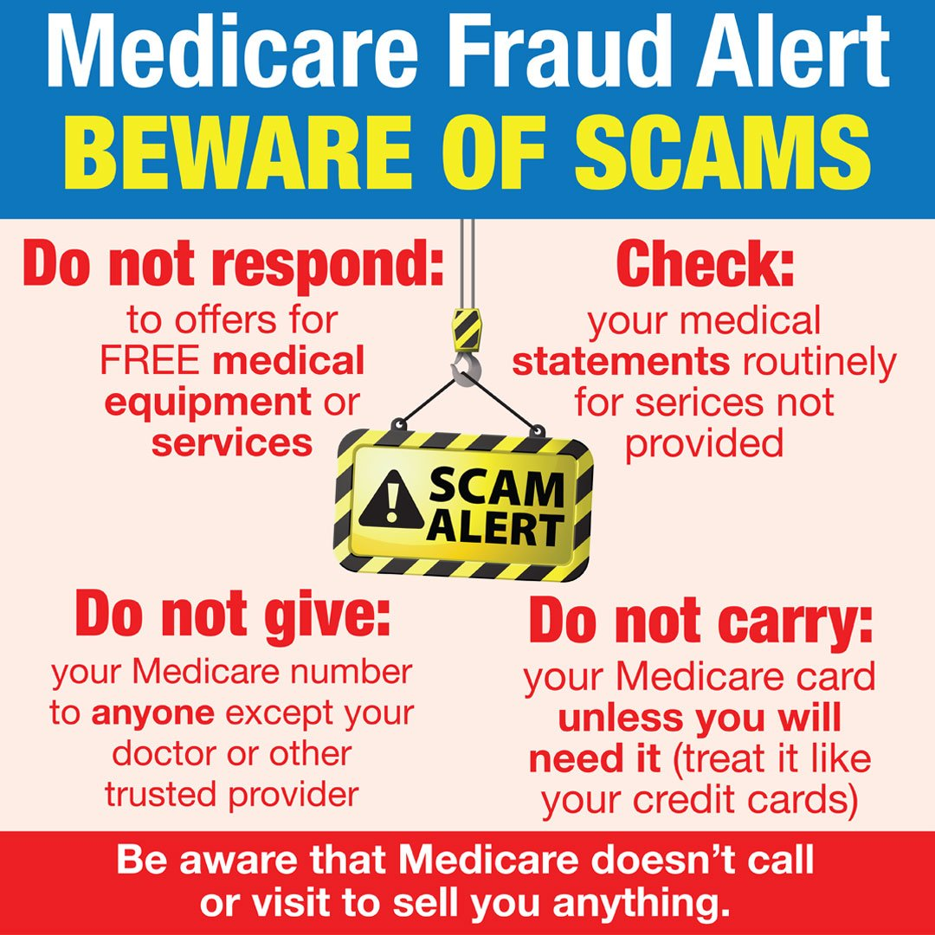
4
Seniors Are Often Targeted By:
- Medicare & Social Security scams
- Fake tech support calls
- Grandparent emergency scams
- Investment or charity scams
✔ Senior Safety Checklist
- ☐ I do not give information to unexpected callers
- ☐ I hang up and call back using a trusted number
- ☐ I never pay with gift cards or wire transfers
- ☐ I talk to family or a trusted person before large decisions
- ☐ I review bank statements regularly
- ☐ I ignore prize notices I didn’t sign up for
📌 Remember: Government agencies do not call demanding payment.

✅ SCAM SAFETY CHECKLIST FOR JUSTICE-INVOLVED INDIVIDUALS
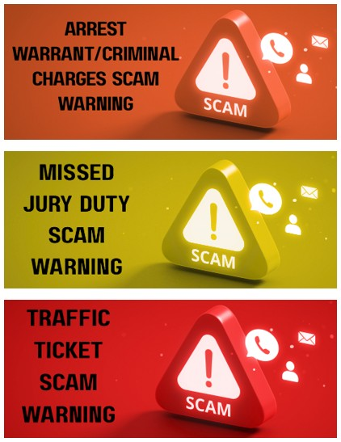
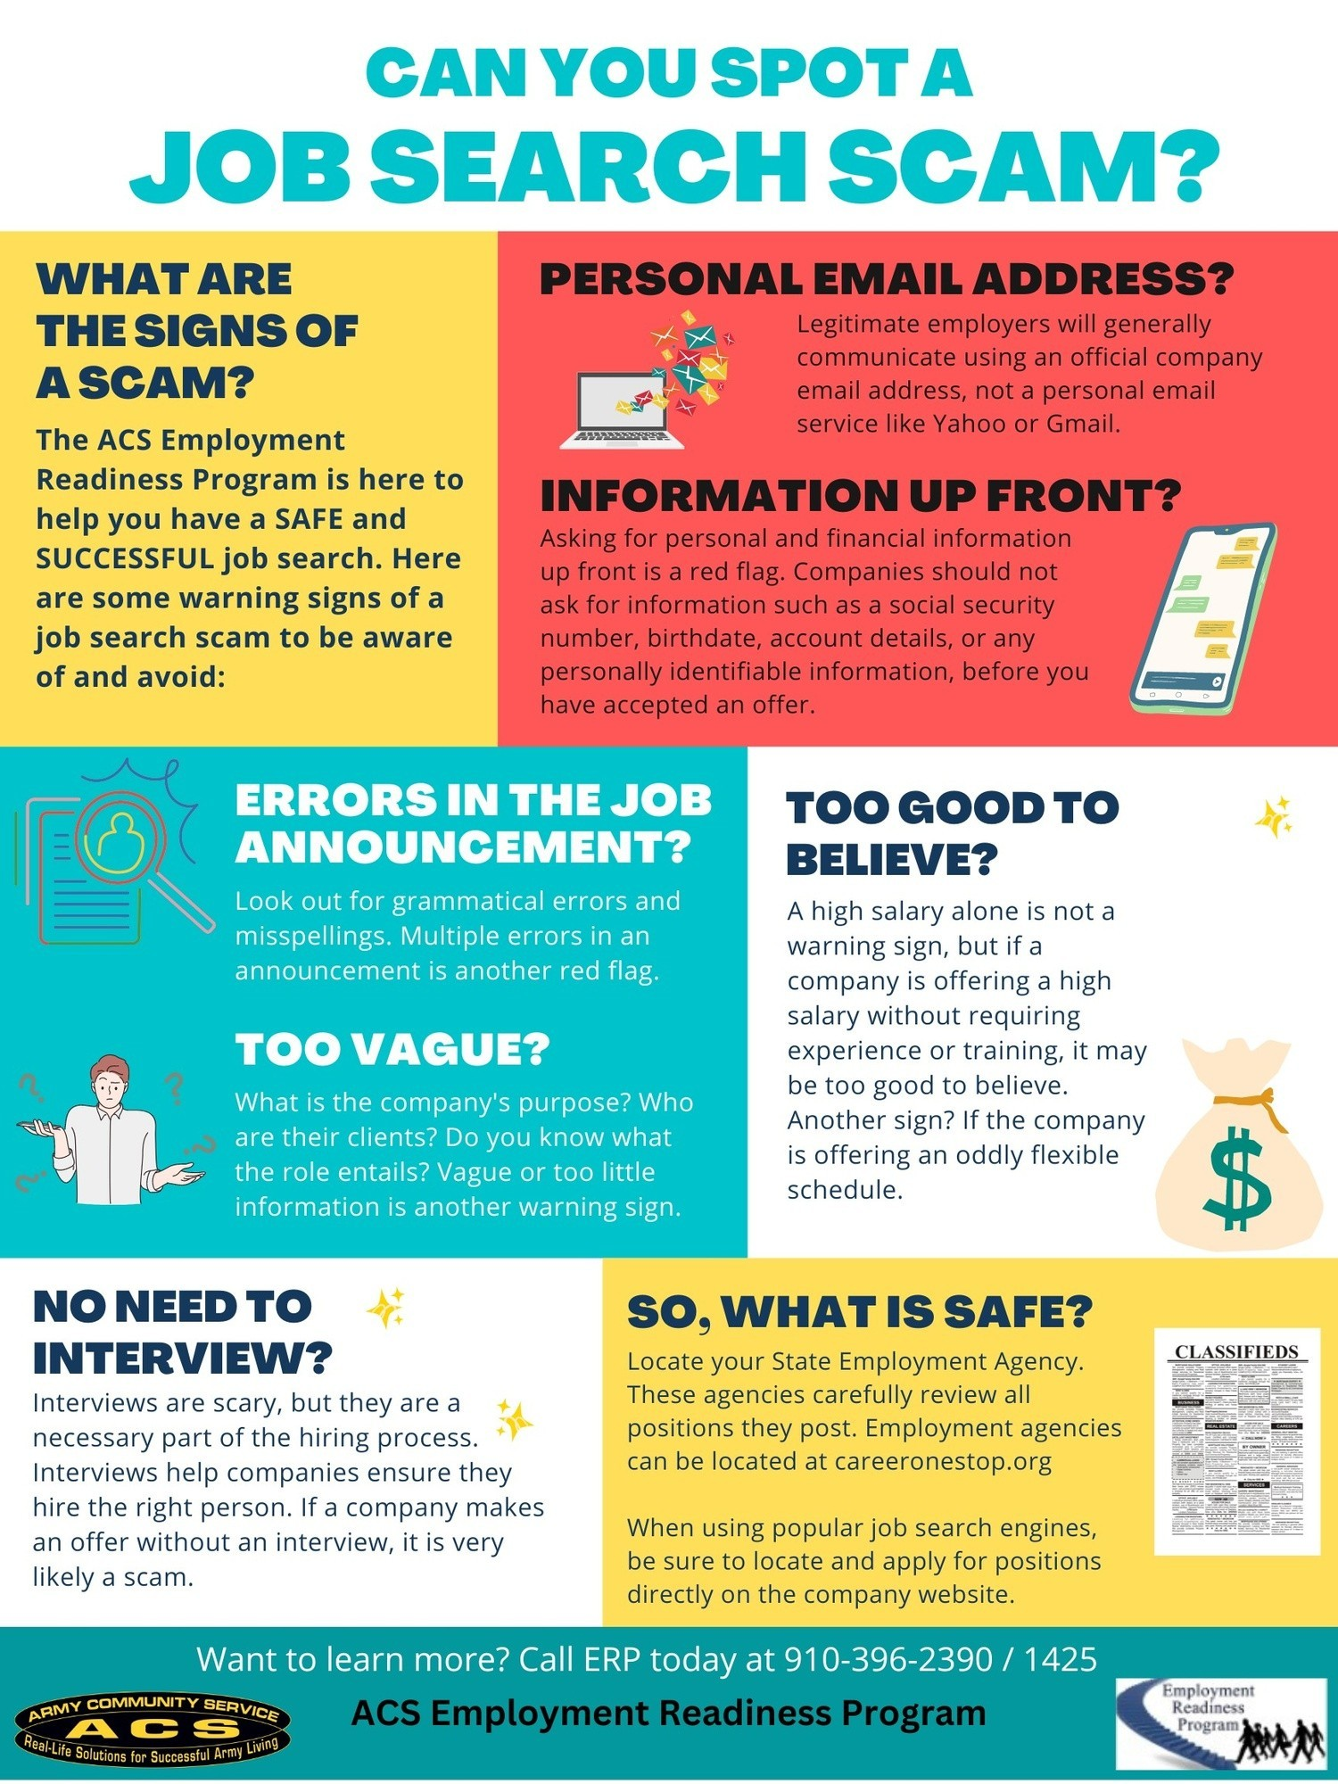
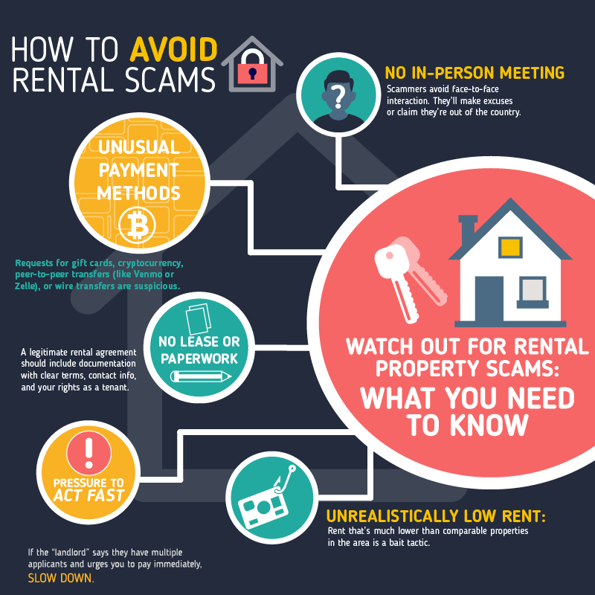
4
Common Scams Targeting Reentry & Justice-Involved People
- Fake probation or court officials
- Job offers requiring upfront fees
- Housing scams asking for deposits before viewing
- Benefit or reentry service impersonation
- “Fast expungement” or legal shortcut scams
✔ Reentry Safety Checklist
- ☐ I verify anyone claiming to be an officer, court, or agency
- ☐ I never pay upfront for jobs or housing
- ☐ I do not share my DOC number, SSN, or release papers
- ☐ I confirm services through official organizations
- ☐ I avoid anyone pressuring secrecy or urgency
- ☐ I ask a case manager or peer before sending money
📌 Important: Legitimate reentry services do not charge surprise fees or threaten reincarceration.

🧠 Training Reminder for Facilitators
- Encourage pausing and asking for help
- Normalize asking questions
- Reinforce that being scammed is not a failure
- Promote peer checking: “Run it by someone”

🏁 Key Message to End Training
Scammers win when people feel rushed, isolated, or afraid.
You stay safe by slowing down, verifying, and asking for support

